hold cntrl and move to copy multiple objects from multiple layers

first silouette, then color, then lighting and shading

<https://www.youtube.com/watch?v=kJ5kmkVb6as&t=71s>

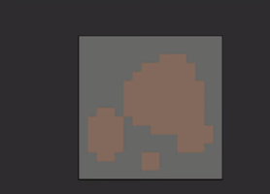

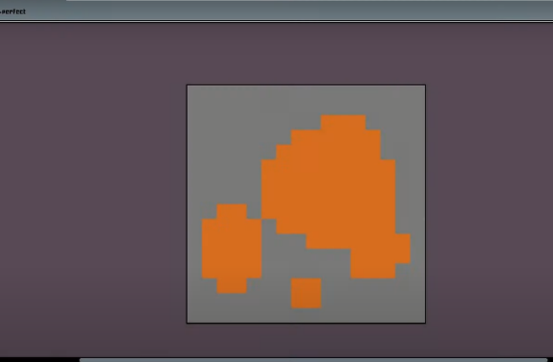

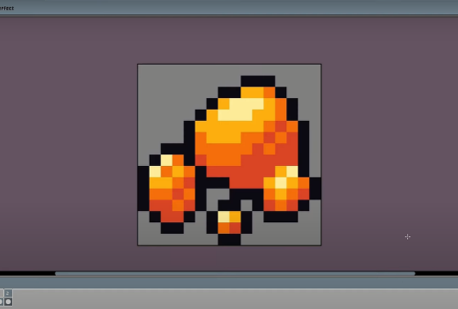

Define light source

shadows

<https://youtu.be/v-ibXM3xBjg?t=300>

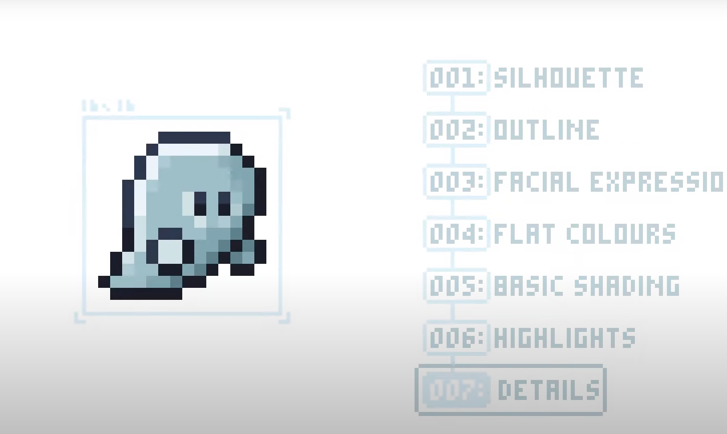

<https://www.youtube.com/watch?v=Z8earctNBxg>

26/3/2022

I animated the knight completely wrong instead of subpixel the value I was changing the alpha

<https://www.youtube.com/watch?v=cs1Gp61yafQ>

To **draw a head** it is difficult to add characteristics. Focus on **Head Shape**, **eyes**(that could be just colored dots) and **hair/head gear**(aka crown, hood)